**Density anomaly PV**

Bailey Avila, 01/09/2023

**Purpose:**

Using a nonlinear run initialized with a density anomaly, we see the formation of VM and its signature in enstrophy and PV over time. We can compare the linear and available PV values to see where the nonlinear model breaks down under linear evaluations.

**Model setup:**

We analyze 2 runs (linear and nonlinear), initialized with zero flow and only a density anomaly in the center of the domain. This anomaly is gaussian in X, Y, and Z.

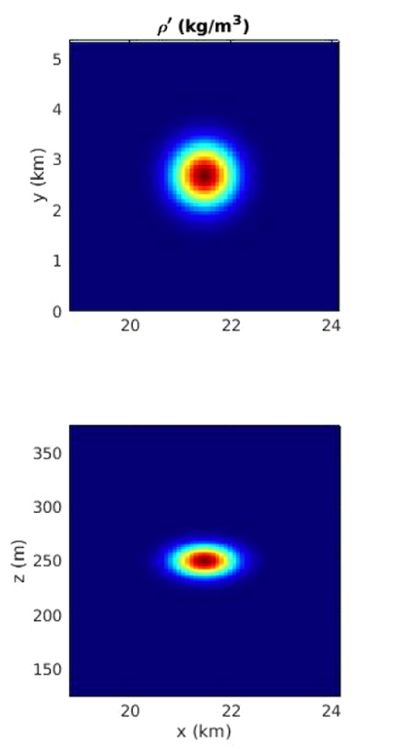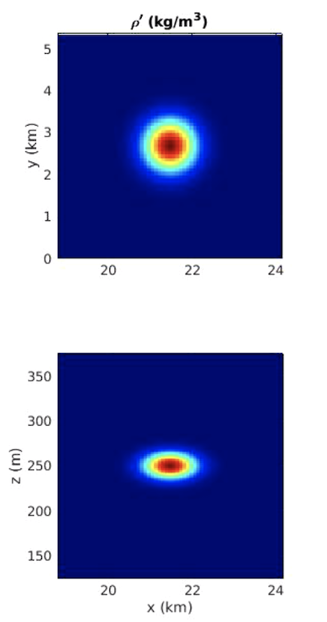

**Analyses:**

For each run, we compute the volume averaged enstrophy from both linear PV and APV, and then plot each value as a time series.

Additionally, we plot energy over time to see if the energy change matches the enstrophy change, or if we have the changes in energy that we expect.

Lastly, each run is seeded with 100 particles and we track PV following the particles. We can follow particles within the anomaly and outside of the anomaly and see how PV changes in each case, then compare it between the linear and nonlinear runs.

**Equations:**

APV =

= (1/s)

LinearPV = (1/s3)

Nonlinear enstrophy = (1/s2)

Linear enstrophy = (1/s6)

**Results:**

Initially in the nonlinear run, figure 1a, wave energy shows a peak which is consistent with nonlinear terms being turned on and applying a linear decomposition. We see already that nonlinearity messes up the linear approximation. Vortex energy rapidly drops at the first time step, much faster than in the linear run (figure 1b).

b

a

Figure 1: Energy over time separated into wave (top) and vortex (bottom) for a) the nonlinear run, and b) the linear run. *Note: nonlinear run was run only for 7 days, similar to the particle data for the linear run.

Linear enstrophy in the nonlinear run has an immediate spike at the very first time step. This was also observed in the Prandtl number runs when nonlinear terms were turned on, consistent with the idea of nonlinearity messing up a linear calculation. We see also an increase in nonlinear enstrophy coinciding with anomaly beginning to adjust. This leads us to believe some of the linear enstrophy increase is due to the adjustment, but a spike of that magnitude is also partially due to the overall nonlinearity.

Figure 2: linear enstrophy (left) and nonlinear enstrophy (right) for nonlinear run with single density anomaly adjusting geostrophically

Following particles, we look both within the anomaly and far away from the anomaly, as was done for the linear run. Here we see the linear and available PV plots are similar, where they follow the same trend but the magnitude is smaller for the APV (figure 3b) in the middle of the anomaly. Away from the anomaly, linear and available PV do not match, where APV is an order of magnitude smaller than linear PV (figure 3d). In comparison, the linear run had APV which was orders of magnitude *larger* than the linear PV. This can be attributed to computing a nonlinear value in a linear run, where the larger linear PV in the nonlinear run is attributed to computing a linear value for a nonlinear run.

a

b

c

d

Figure 3: a&c) linear (left) and available (right) PV over time following particles, b&d) linear PV and APV plotted together over time. Particle locations are: in the middle of the anomaly (top), and away from the anomaly (bottom).

Top: Density anomaly (initial condition) with particle locations

Bottom: available PV over time for each particle (overplot)

06

16

26

36

46

56

66

76

86

96

06 16 26 36 46 56 66 76 86 96

Blown up APV vs time plots

36 46 56

06 16 26

86 96

66 76

